# Normalizer, Aggregator and Rank transformations

I have a csv file with the list of the sales details of the employees in the last 4 quarters. I want to find the top performers based on their numbers for the last 4 quarters. (Emp name, which quarter, sales).

Goto Data Integrations -> New -> Mapping

Source: Flatfile connection, Sales.csv

Add a Normalizer transformation. In the Normalized Field, click ‘Add existing Fields’ and select the following two fields.

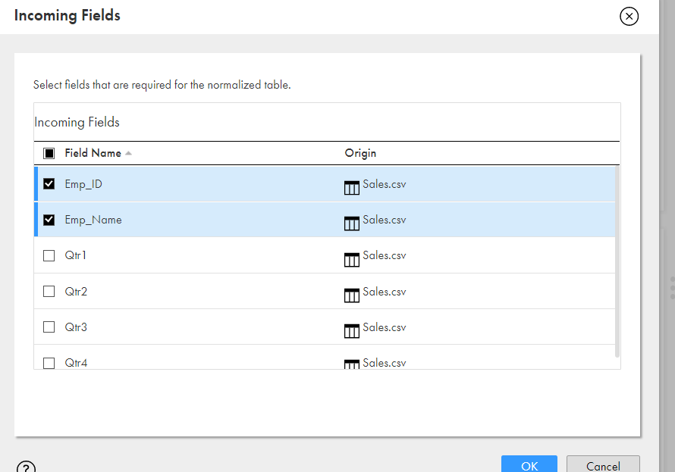

From ‘Create new field’ option, add the field ‘Quarter’ and set it to occur 4 times.

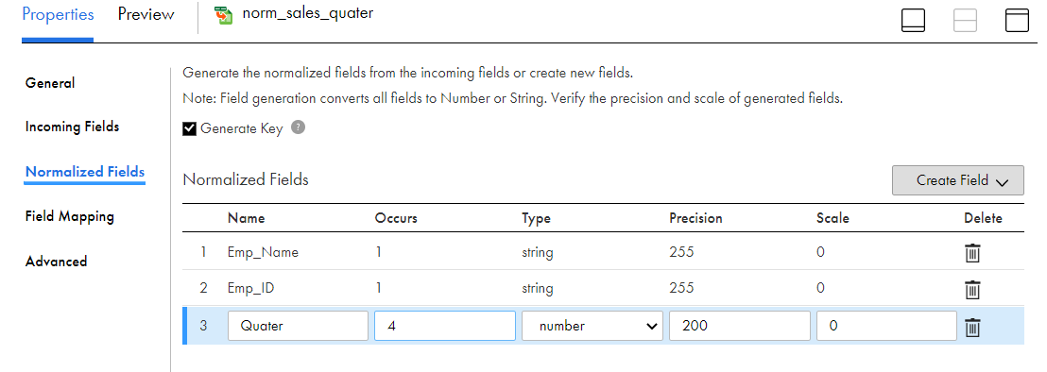

Map the corresponding fields.

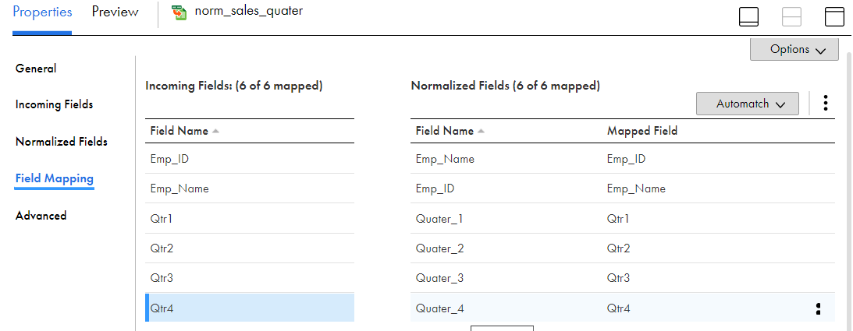

Add an Expression Transformation. In the ‘Expression’ tab, create an output field as follows.

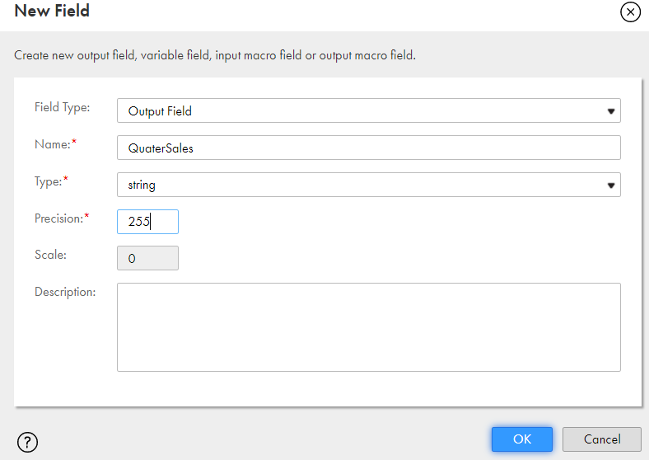

Configure the expression with the following:

DECODE(TRUE,GCID_Quater=1,'Qtr1',GCID_Quater=2,'Qtr2',GCID_Quater=3,'Qtr3',GCID_Quater=4,'Qtr4')

Create a Target (Normalizer.csv) and select the following incoming fields.

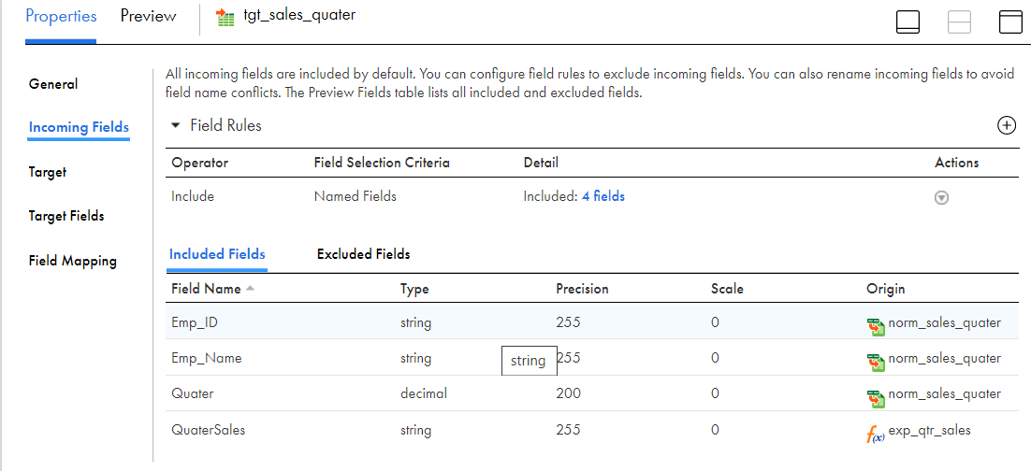

Map the Target fields.

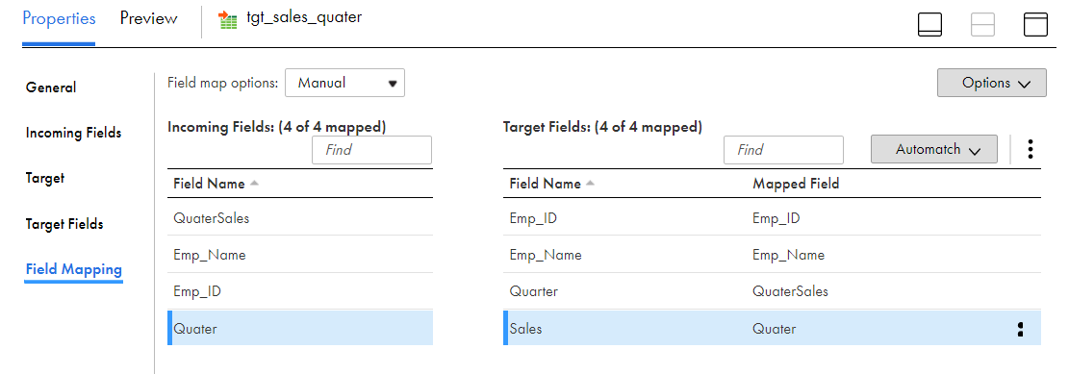

Run the mapping.

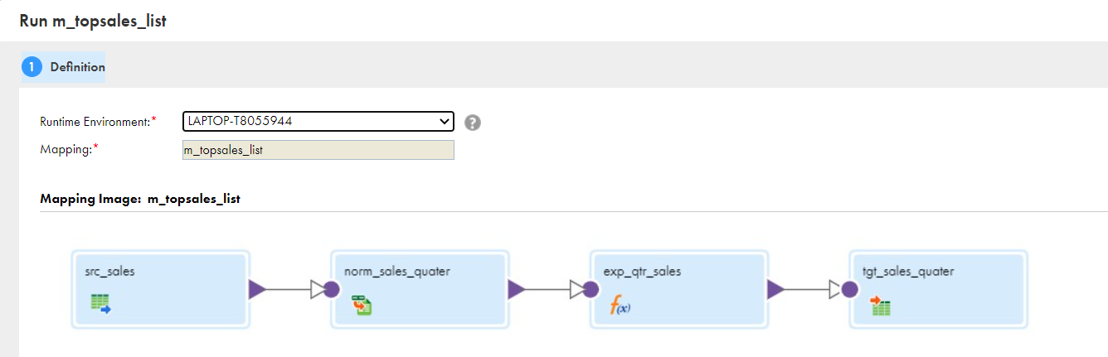

The Normalized file is generated, with 4 rows for each employee, stating the sales in each quarter.

## Adding Aggregator and Rank transformations

Add an aggregator transformation to the mapping as a branch after the normalizer. Calculate the sales percentage of each employee (assuming the target for sales per quarter is 100).

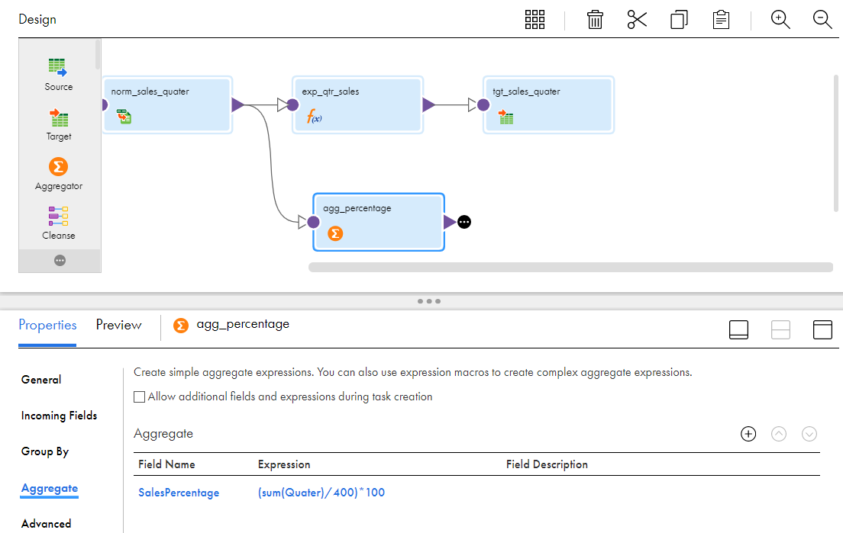

To find the top 20 employees based on the sales, add a ‘Rank transformation’ and based on the ‘SalesPercentage’ select the top 20 rows.

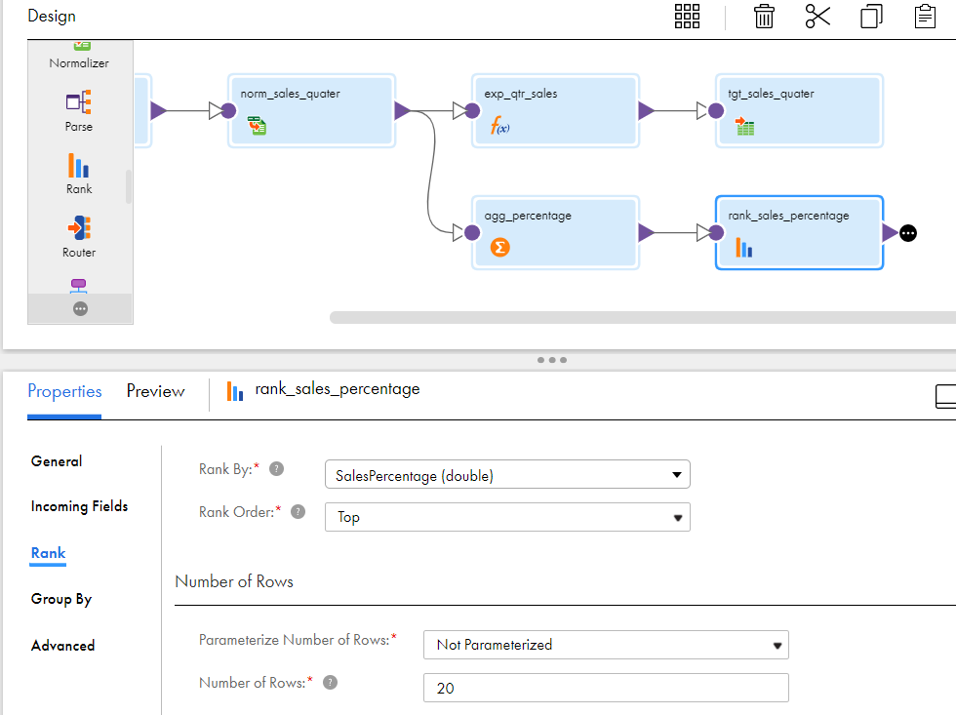

Add a target (Aggregated.csv) and select the following incoming fields.

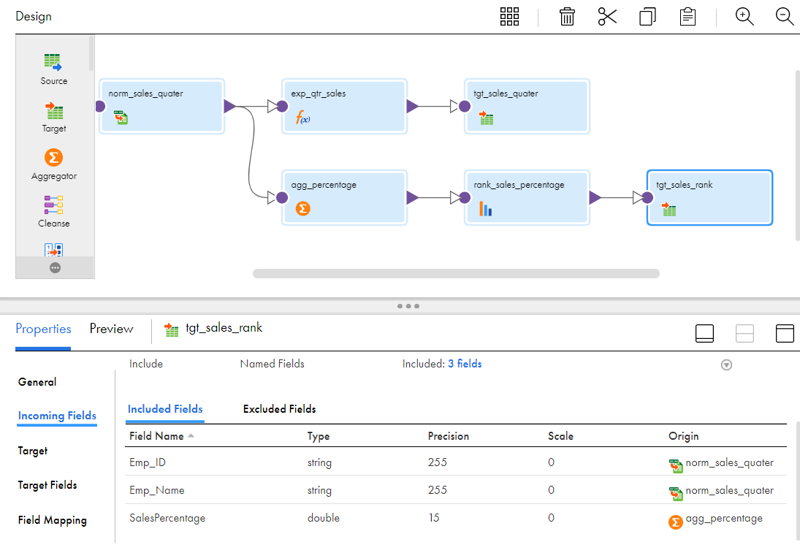

Map the incoming fields to the target fields.

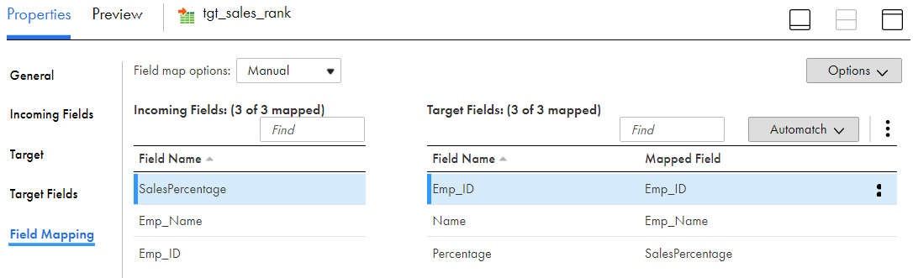

Save and run the mapping.

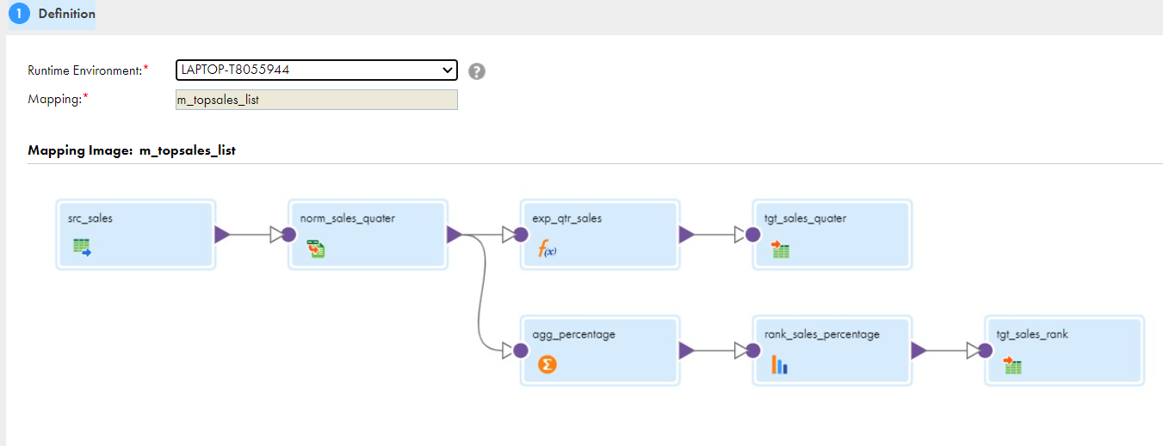

The list of top 20 employees based on the sales percentage is written to the target file.